**FOR IMMEDIATE RELEASE**

**Media Contact:** Emily Willette

856-489-8654 x1025

[emily.willette@smithpublicity.com](mailto:emily.willette@smithpublicity.com)

**LEAD WITHOUT BURNOUT: GROWTH WITH LESS STRESS FOR YOU AND YOUR TEAM**

***Top CEO Coach Reveals Proven Process for Achieving Work/Life Optimization, Growing Your Business More Effectively, & Enhancing Well-Being for You & Your Team***

**MEET RYAN RENTERIA**

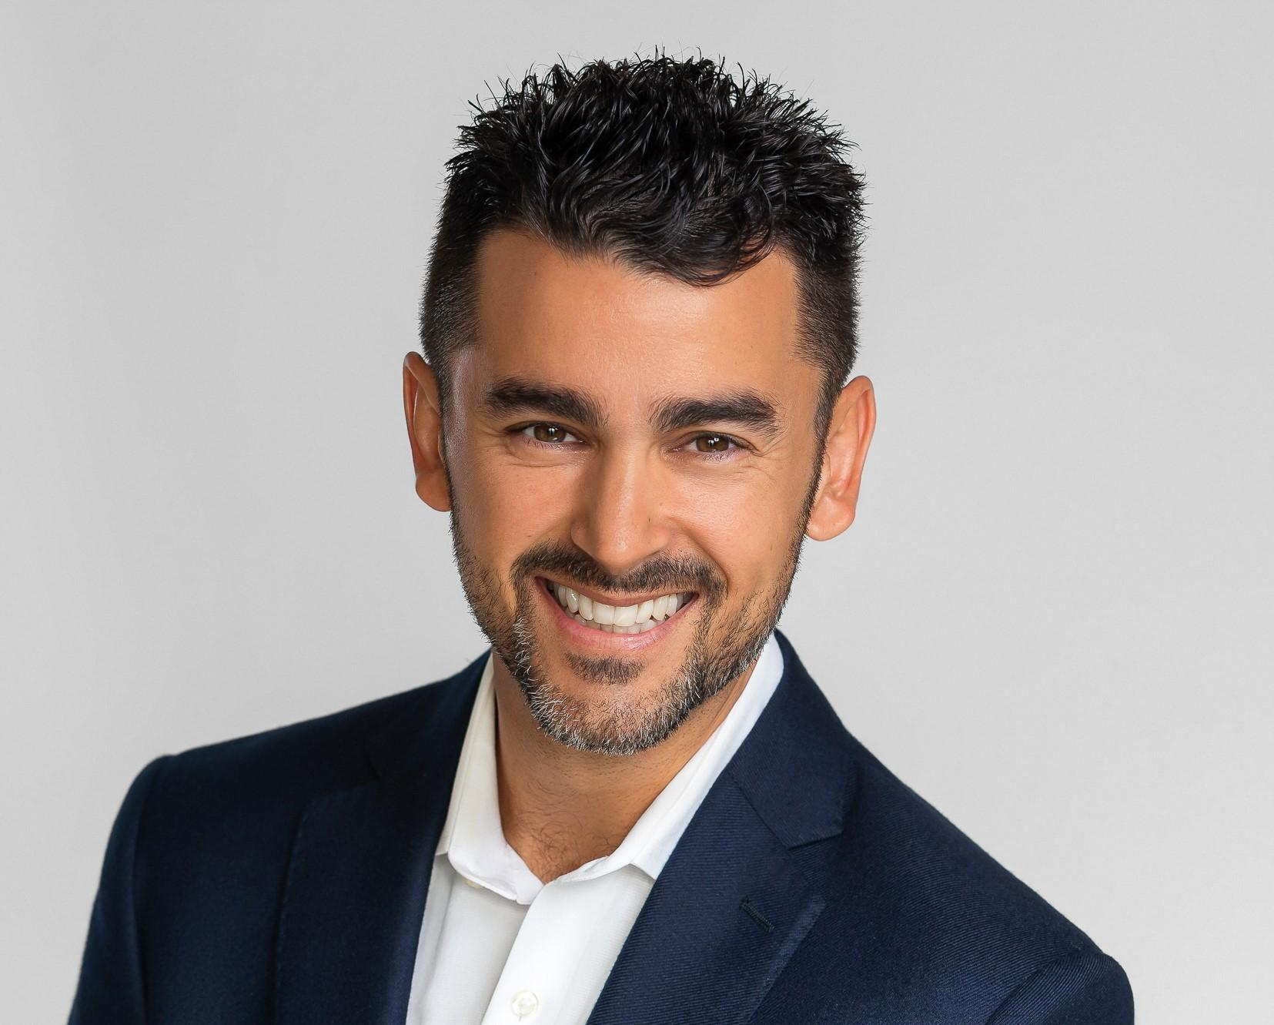

[Ryan Renteria](https://thestretchfive.com/about-ryan-renteria/) is a CEO coach, diverse board director, public speaker, and the founder of [Stretch Five](https://thestretchfive.com/), a leading executive coaching firm. He helps leaders maximize professional and personal performance and growth through expertise in topics including leadership, communication, talent management, relationships, and health. Ryan coaches CEOs to build bold visions, hire and develop top talent, motivate them to achieve outstanding results, and be better leaders.

He spent nine years at Goldman Sachs and large hedge funds. Ryan became a partner and managing director of consumer investments at the age of twenty-five and, after strong returns, left Wall Street for charitable pursuits. Ryan spent nine years as an analytics advisor to Indiana Pacers coaches and executives. He was also part of the ownership group of the Milwaukee Brewers’ AA Minor League Baseball team and a potential MLS team.

Ryan earned a BA in economics from Stanford with highest honors for academic excellence from Stanford’s Latino community. He is the author of the new book, ***Lead without Burnout: Growth with Less Stress for You and Your Team***. This book received the Distinguished Favorite Award from the 2024 NYC Big Book Awards and is a 2024 *Foreword* INDIES Book of the Year Finalist. It is also an Amazon bestseller, reaching No. 1 as a bestselling new release and the Top 10 bestsellers in work-life balance. The acclaimed guidebook provides executives with the tools to transcend boundaries to effectively balance life and work while creating a culture of enhanced well-being.

**ABOUT THE BOOK**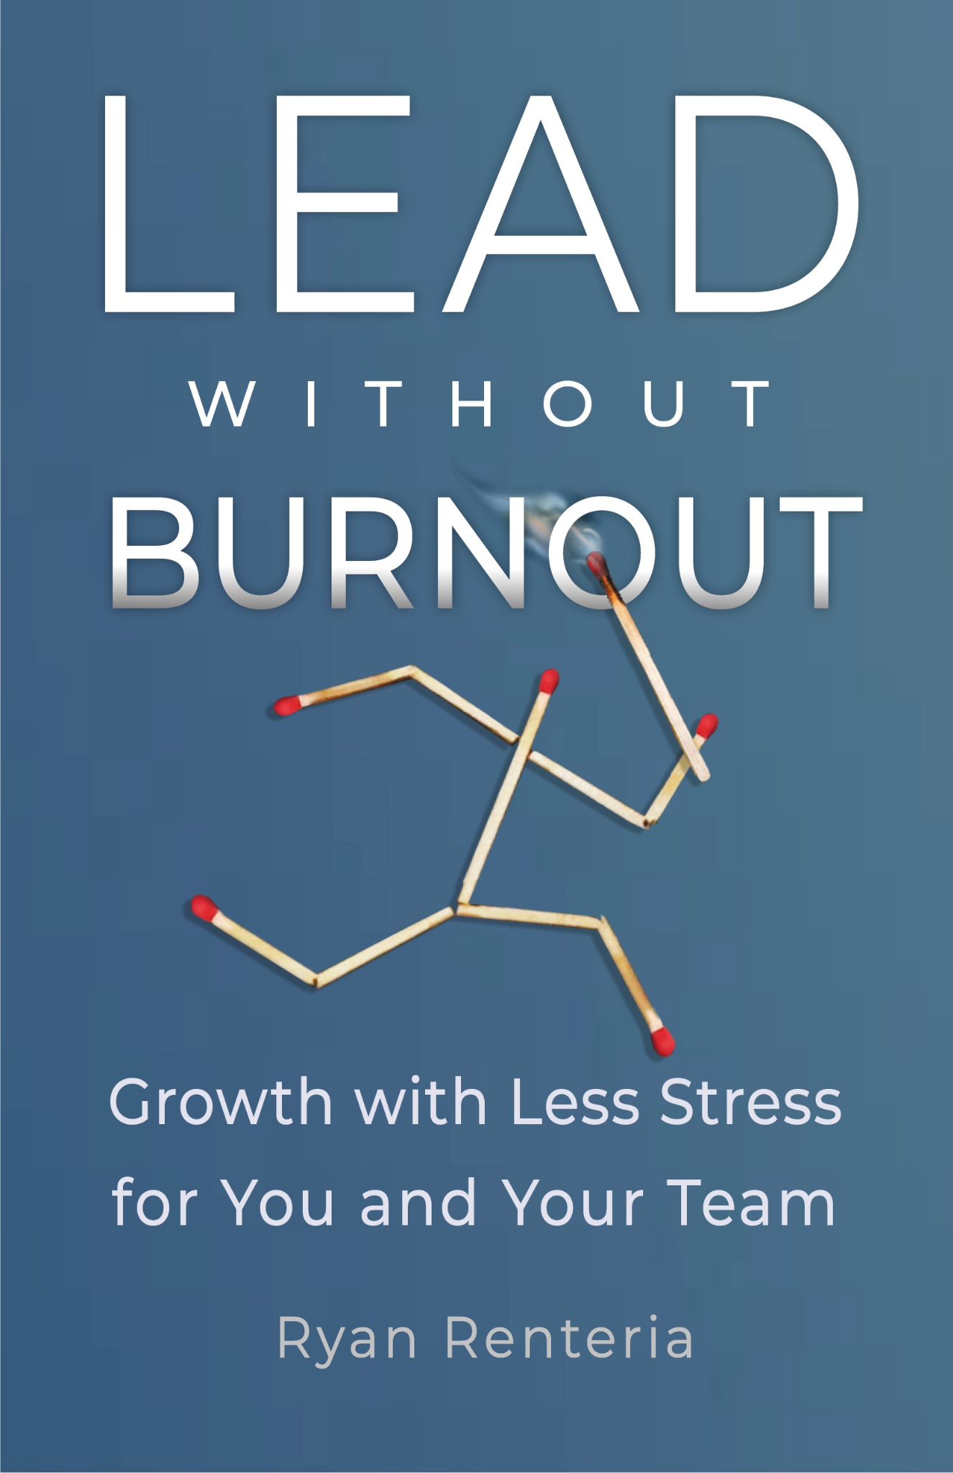

***Lead without Burnout is an award-winning Amazon bestseller in both hardcover and paperback!***

The key to work/life optimization and burnout elimination is to create a world-class culture of well-being with best practices for attracting top-level players. You can entrust these talented team members with more ownership over some of your responsibilities and they will be motivated to handle them. Then, you optimize productivity and decision-making to free up more time and mental energy for everyone.

As a business leader, you’re under enormous pressure. Fierce competition and unpredictable challenges create constant stress. Your perfectionism and work ethic compel you to devote yourself to your career while putting relationships—and even your health—on hold. Burnout seems inevitable.

In [***Lead without Burnout: Growth with Less Stress for You and Your Team***](https://www.amazon.com/Lead-without-Burnout-Growth-Stress-ebook/dp/B0CL7VVHGH/ref=sr_1_1?crid=1ZC5EJJ154N4A&keywords=Lead+Without+Burnout%3A+Growth+with+Less+Stress+for+You+and+Your+Team&qid=1697814667&s=books&sprefix=lead+without+burnout+growth+with+less+stress+for+you+and+your+team+%2Cstripbooks%2C120&sr=1-1), renowned CEO Coach Ryan Renteria provides a roadmap to optimizing your professional and personal growth. He emphasizes that you can be great at everything that matters the most to you. He shatters the myth that you must sacrifice ambitious professional growth to achieve better balance and enjoy stronger mental and physical health. Discover the secret to successfully scaling your business while enjoying quality time with friends and family.

Learn to transcend boundaries to effectively balance life and work while creating a culture of enhanced well-being. Gain access to evidence-based, actionable tools to help you optimize both professional and personal growth. ***Lead without Burnout***shows you how to slash stress, achieve phenomenal business performance, and live a happy and fulfilled life.

***Lead without Burnout: Growth with Less Stress for You and Your Team* is now available on** [**Amazon**](https://www.amazon.com/Lead-without-Burnout-Growth-Stress-ebook/dp/B0CL7VVHGH/ref=sr_1_1?crid=1ZC5EJJ154N4A&keywords=Lead+Without+Burnout%3A+Growth+with+Less+Stress+for+You+and+Your+Team&qid=1697814667&s=books&sprefix=lead+without+burnout+growth+with+less+stress+for+you+and+your+team+%2Cstripbooks%2C120&sr=1-1) **and everywhere books are sold. **All profits from book sales will be donated to mental health charities.\*\***

**SAMPLE INTERVIEW QUESTIONS**

* How can leaders achieve better work-life optimization, stronger mental and physical health, and more time with friends and family without sacrificing ambitious professional aspirations?
* Why are traditional mission statements and values ineffective, and what is your solution for replacing them with something more effective?
* Why are “A” players so important to radically improving your life, and what elements of culture help you attract them?
* Who is experiencing mental health challenges in the workplace and how do you address them?
* What are some best practices for the hiring process that will help you land “A” players?
* If you just delegate most things, how do you ensure that stress and burnout don’t just get shifted downstream?
* What are some ways to optimize time and productivity?
* How do we make better decisions?

**DISCUSSION TOPICS**

* Leaders and their teammates CAN achieve greater freedom, family time, and health without sacrificing big business goals.
* Employees with a strong work-life balance are 21% more productive. Imagine making leading without burnout your top priority and your profits improve 20% all the while making your personal life better.
* 85% of companies that offer work-life balance programs for their employees report an increase in productivity.
* Self-actualization stems from flourishing in the several aspects of life that matter most to you, not from working an unbearable amount of hours to develop the most dominant company in the world and become obscenely wealthy.
* *Lead without Burnout* details the culture critical to setting leaders free from the stress and workload that hurts their health and relationships.
* Trust and delegate to “A” (top level) players to free up time for strategic thinking and mental recharging needed for growth.
* How can you grow profits if you lose your talent to better mental health cultures?
* What do the 3 largest companies in the U.S. have in common? Apple, Microsoft & Google’s former CEOs have all said that their #1 key to success has been hiring great people. There’s a unique hiring process that will land you more “A” players.
* 81% of managers said they’re more likely to stay at a company that has high-quality mental health resources.
* 1 of every 8 Americans suffer from mental health issues. How about CEOs? 1 in every 2. That’s 4 times as many! Half of your C-Suite could be struggling with mental health issues.

**TESTIMONIALS**

*“From working on our IPO in 2002 to becoming a shareholder, Ryan challenged us with insightful questions around our strategy and growth initiatives. His guidance will help leaders aiming to grow their business and create a culture of well-being.”*

**—Ed Stack, exec chairman and fmr CEO of Dick’s Sporting Goods**

*“Ryan was one of my most trusted advisors when I coached the Pacers. I valued his input on strategy tremendously as it was clear how much preparation went into his work. With his meticulous approach and extensive experience advising leaders, I know his book will help leaders striving for professional growth without burning out.”*

**—Frank Vogel, head coach of the Suns, the Lakers 2020 title team, and formerly the Pacers and Magic**

*“Ryan always challenged our executive team with tough questions that demonstrated his level of preparation and knowledge of strategy and leadership. Having known him for over twenty years, I’m not surprised he has been a trusted advisor to leaders from the C-Suite to the NBA. I know he will help leaders seeking to improve their business strategy and growth while prioritizing well-being.”*

**—Ron Sargent, former chairman and CEO of Staples**

*“Early in the interview stage I already knew Ryan was going to add significant value to the Pacers. In his early stages of growing our analytics efforts, I read all his analyses and enjoyed the unique insights and clear communication. I’m confident he’ll be quite successful using his skill set, passion, and integrity to help executives take their growth to new heights.”*

**—Herb Simon, owner of the Pacers; chairman emeritus of Simon Property Group**

*"Today more than ever, leaders need the right tools to grow their businesses without burning out themselves or their talented team members. Ryan’s substantial experience working with CEOs and his thoughtful approach to his work should prove beneficial to business leaders who read this book.”*

**—Ron Boire, fmr CEO of Barnes & Noble and Brookstone, president at Sony**

*"Ryan and I have had great conversations over the years around leadership, evidence-based processes, and business strategy. He effectively communicates his insights in these areas to help leaders optimize their culture and scalability.”*

**—Josh Wolfe, managing partner at Lux Capital**

*“Ryan’s process-oriented approach and diverse experience enables great leadership insights across finance, business, and sports.”*

**—Dmitry Balyasny, managing partner of Balyasny Asset Mgmt**

**CONTACT INFO**

**Ryan Renteria is available for interviews/Q&As, expert commentary, contributed articles/essays and other features, as well as speaking engagements and other media appearances. For more information, visit:**

**Website:** [**https://TheStretchFive.com/**](https://thestretchfive.com/)

**LinkedIn:** [**https://www.linkedin.com/in/ryan-renteria/**](https://www.linkedin.com/in/ryan-renteria/)

# # #